Group Members: Emir Dostovic

A) Long Term Goal: Establish a functional basis and framework for the application. Meaning have a fully functional prototype with all the features implemented. This includes user profiles, an optimizable calendar, data sharing feature between collaborators and administrators, a priority scrollbar to indicate the importance of an assignment and how it’ll be considered for reminders, etc.

B) Possible stakeholders could include the collegiate system itself or marketing agencies.

C) Potential issues that the group could face would be time constraints with everyone having full course loads etc.

Discovery Questions:

1) What are the biggest challenges you face when using scheduling apps?

2) What would success look like for you in addressing these challenges?

3) Have you tried any solutions to address these challenges in the past?

4) What features or functionalities would be most valuable to you for time management?

5) What factors influence your decision to purchase a product?

6) What criteria do you use to evaluate and compare different options?

7) How do you prefer to learn about new products or solutions?

8) What sources do you trust for information related to the product?

D)

User Persona: Sarah

Sarah is a 24 year old, diligent graduate student pursuing a Master's degree in Environmental Science at a reputable university. Sarah is passionate about conducting research that contributes to sustainable development and environmental conservation. As she juggles multiple courses, research projects, and part-time work, Sarah often finds it challenging to stay organized and manage her academic commitments effectively.

Sarah relies heavily on digital tools to streamline her academic workflow and maintain productivity. She envisions an app that caters specifically to the needs of graduate students like herself, offering a centralized platform for organizing her research materials, managing deadlines, and collaborating with peers on group projects. With a busy schedule that includes attending classes, conducting fieldwork, and analyzing data, Sarah values the ability to access her academic resources seamlessly across different devices and stay updated on her progress through customizable alerts and reminders.

.

E) User Journey Map for Sarah:

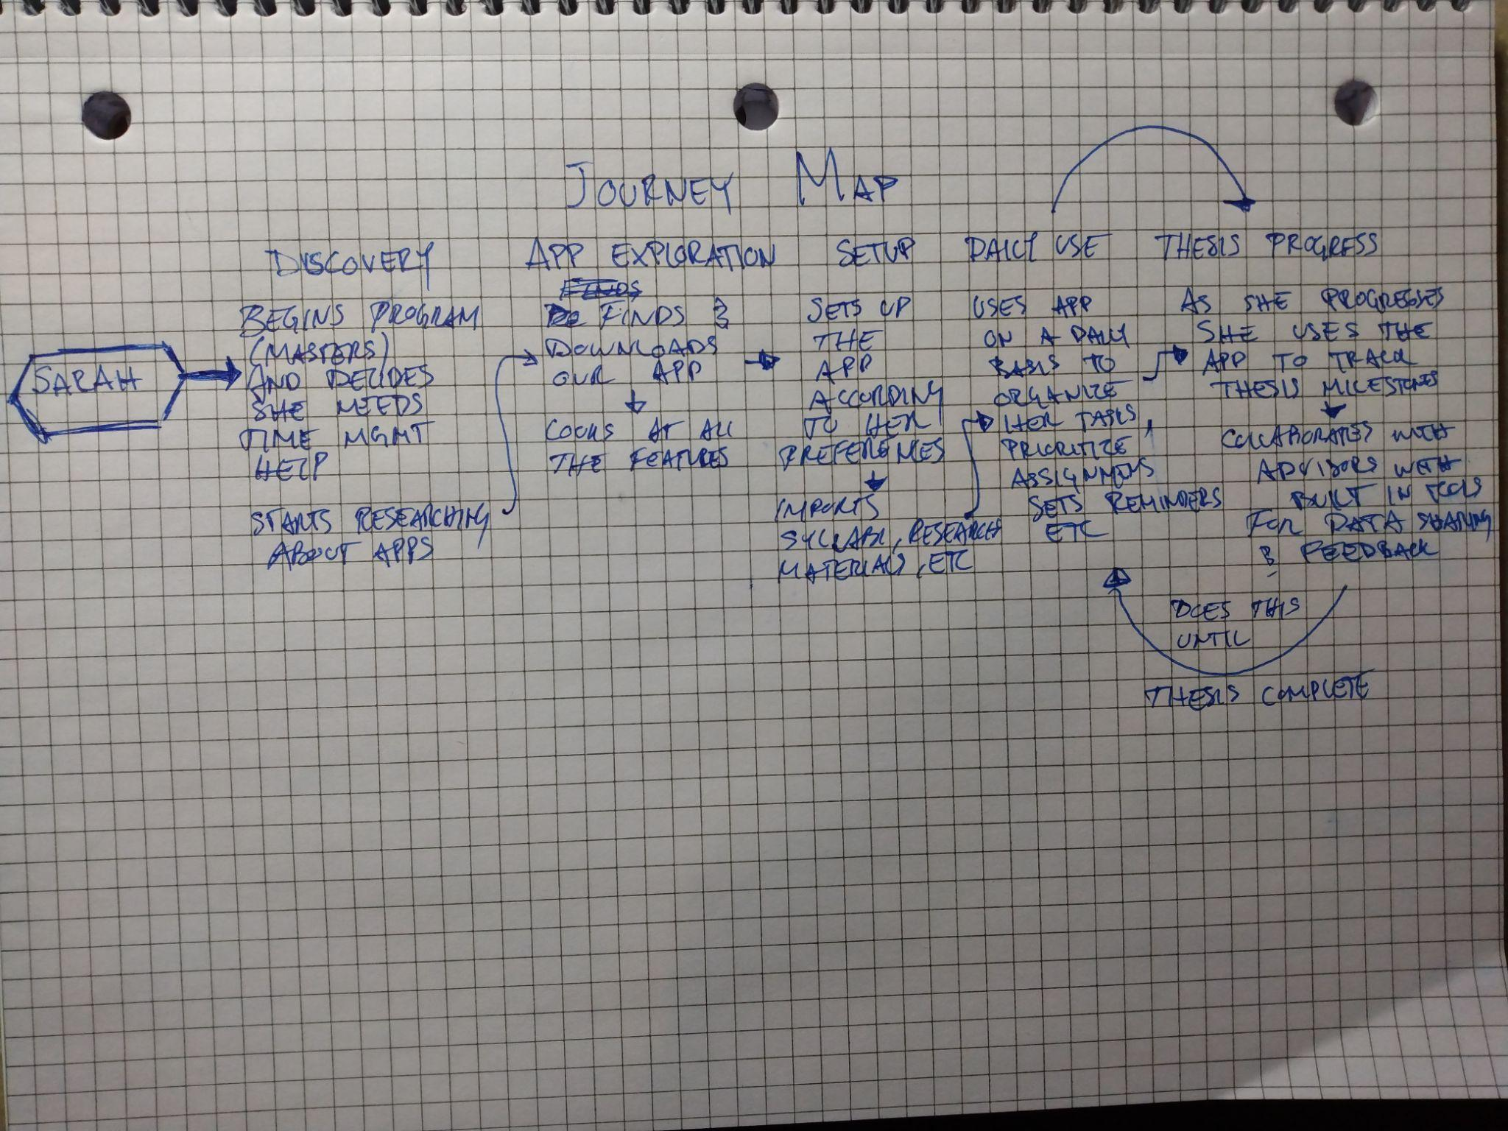

F) HMW improve the app's citation management functionality to streamline the process of organizing and citing references for research papers and theses?

HMW integrate seamless integration with academic databases and libraries to simplify the process of accessing and managing research materials within the app?

HMW enhance data visualization capabilities within the app to help graduate students track their progress, analyze trends, and identify areas for improvement in their academic pursuits?

Group Journey Map:   
Today was my first day back in class in two weeks (2/12/24). I was unable to locate or collaborate with any of the team members for the group I was assigned to. I’ve decided to use the Journey Map that I've already created as there are no other ones to compare to or pick any particular task from.

